Batch: E-2 Roll No.: 16010123325

Experiment No. 03

TITLE: Demonstrate the use of Bootstrap

AIM: To use bootstrap (open source front-end development framework) for the creation of web pages.
______________________________________________________________________
Expected Outcome of Experiment: Re_design of web pages using various HTML, CSS tags with bootstrap.
_______________________________________________________________
Books/ Journals/ Websites referred:

http://getbootstrap.com/getting-started
_____________________________________________________________________

Problem Statement:

- Students have to re-design web-pages developed in Experiment 1 and 2 by using bootstrap.

- Create a webpage using bootstrap with following features,

i) use a container to set the content's margins dealing with the responsive behaviors of layout.
ii) shape the image into a circle
iii) use bootstrap grid system
iv) create basic pagination
v) insert search icon(glyphicon)

Description of the application implemented with output:
ECOLEARN is a responsive, Bootstrap-based educational landing page designed to promote awareness and learning about environmental issues. It utilizes modern web technologies to offer an aesthetically appealing and informative user interface, aimed at encouraging users to explore eco-conscious topics.

Code-
<!DOCTYPE html>
<html lang="en">
<head>
<meta charset="UTF-8">
<meta name="viewport" content="width=device-width, initial-scale=1.0">
<title>ECOLEARN - Environmental Education Platform</title>
<link href="https://cdn.jsdelivr.net/npm/bootstrap@5.3.0/dist/css/bootstrap.min.css" rel="stylesheet">

<link rel="stylesheet" href="https://cdnjs.cloudflare.com/ajax/libs/font-awesome/6.0.0/css/all.min.css">
<style>
:root {
--primary-color: #2A9D8F;
--secondary-color: #264653;
}

.hero-section {
background: linear-gradient(rgba(42, 157, 143, 0.8), rgba(38, 70, 83, 0.9)),
url('https://source.unsplash.com/1600x900/?nature,environment');
background-size: cover;
height: 100vh;
color: white;
}

.navbar {
background-color: var(--secondary-color) !important;
}

.btn-success {
background-color: var(--primary-color);
border-color: var(--primary-color);
}

.btn-success:hover {
background-color: #238276;
border-color: #238276;
}

.student-info {
position: fixed;
bottom: 20px;
right: 20px;
background-color: rgba(42, 157, 143, 0.9);
color: white;
padding: 30px;
border-radius: 5px;
box-shadow: 0 2px 5px rgba(0,0,0,0.2);
}
</style>
</head>
<body>

<nav class="navbar navbar-expand-lg navbar-dark bg-dark fixed-top">
<div class="container">
<a class="navbar-brand" href="#">
<i class="fas fa-earth-americas me-2"></i>
ECOLEARN
</a>
<button class="navbar-toggler" type="button" data-bs-toggle="collapse" data-bs-target="#navbarNav">
<span class="navbar-toggler-icon"></span>
</button>
<div class="collapse navbar-collapse" id="navbarNav">
<ul class="navbar-nav ms-auto">
<li class="nav-item"><a class="nav-link" href="#">Home</a></li>
<li class="nav-item"><a class="nav-link" href="#">Courses</a></li>
<li class="nav-item"><a class="nav-link" href="#">About</a></li>
<li class="nav-item"><a class="nav-link" href="#">Contact</a></li>
</ul>
</div>
</div>
</nav>

<section class="hero-section d-flex align-items-center">
<div class="container text-center">
<h1 class="display-1 mb-4">
<i class="fas fa-leaf me-3"></i>ECOLEARN
</h1>
<h2 class="mb-4 fw-light">Nurturing Knowledge, Growing Future</h2>
<p class="lead mb-5">Join us in building a sustainable tomorrow through education</p>
<button class="btn btn-custom btn-lg me-3 px-4 py-2">Start Learning</button>
<button class="btn btn-outline-light btn-lg px-4 py-2">Explore Courses</button>
</div>
</section>

<section class="container my-5">
<div class="row">
<div class="col-md-4 mb-4">
<div class="card">

<div class="card-body">
<h5 class="card-title">Sustainable Living</h5>
<p class="card-text">Learn how to live a sustainable life and reduce your carbon footprint.</p>
<a href="#" class="btn btn-success">Enroll Now</a>
</div>
</div>
</div>
<div class="col-md-4 mb-4">
<div class="card">

<div class="card-body">
<h5 class="card-title">Marine Conservation</h5>
<p class="card-text">Understand the importance of marine ecosystems and their conservation.</p>
<a href="#" class="btn btn-success">Enroll Now</a>
</div>
</div>
</div>
<div class="col-md-4 mb-4">
<div class="card">

<div class="card-body">
<h5 class="card-title">Waste Management</h5>
<p class="card-text">Learn effective waste management techniques for a cleaner environment.</p>
<a href="#" class="btn btn-success">Enroll Now</a>
</div>
</div>
</div>
</div>
</section>

<nav aria-label="Page navigation example">
<ul class="pagination justify-content-center">
<li class="page-item disabled">
<a class="page-link" href="#" tabindex="-1" aria-disabled="true">Previous</a>
</li>
<li class="page-item"><a class="page-link" href="#">1</a></li>
<li class="page-item"><a class="page-link" href="#">2</a></li>
<li class="page-item"><a class="page-link" href="#">3</a></li>
<li class="page-item">
<a class="page-link" href="#">Next</a>
</li>
</ul>
</nav>

<div class="student-info text-light ">
<p class="mb-3"><strong>Shreyans Tatiya </strong></p>
<p class="mb-3">16010123325</p>
</div>

<script src="https://cdn.jsdelivr.net/npm/bootstrap@5.3.0/dist/js/bootstrap.bundle.min.js"></script>
</body>
</html>

Output-

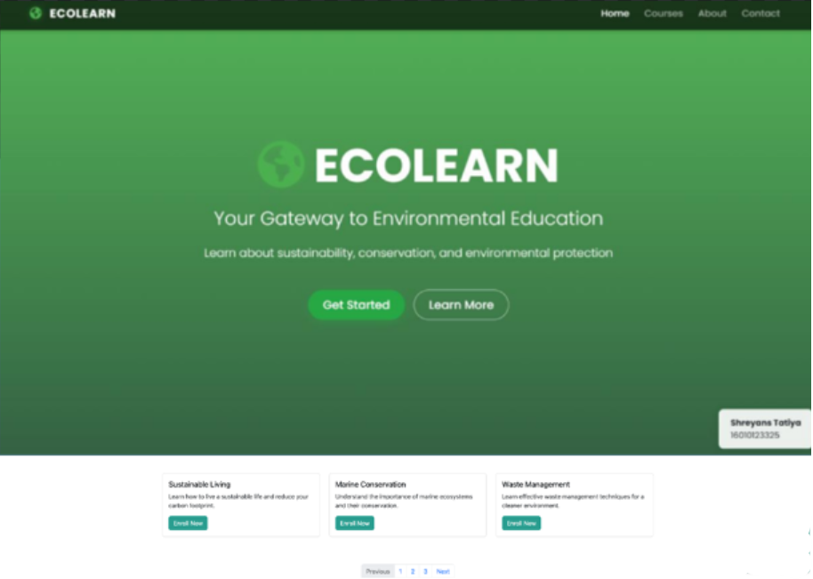

Post Lab Questions:
- What is the use of containers in bootstrap? Explain in detail.
Containers are used to wrap content and provide spacing and alignment in Bootstrap layouts. They help structure your page and are required for using the grid system.

Types:
- .container – Fixed width, responsive at each breakpoint.
- .container-fluid – Full width across all screen sizes.
- .container-{breakpoint} – 100% width until the specified breakpoint (e.g., .container-md).

- Name the classes to achieve the different button styles in bootstrap.
Use the base class .btn with style classes:
Class | Style
.btn-primary | Blue – primary action
.btn-secondary | Gray – secondary action
.btn-success | Green – success messages
.btn-danger | Red – error or delete
.btn-warning | Yellow – warnings
.btn-info | Teal – info messages
.btn-light | Light gray background
.btn-dark | Dark background
.btn-link | Styled like a hyperlink

- Write details about the Bootstrap Grid system.
The grid system in Bootstrap helps create responsive layouts using rows and columns.
- Based on 12 columns.
- Use .row to create a row, and .col, .col-6, etc., to define columns.
- Responsive classes like .col-sm-, .col-md-, .col-lg-, etc., adjust layouts on different screen sizes.

Example:
<div class="row">
<div class="col-md-6">Column 1</div>

<div class="col-md-6">Column 2</div>
</div>

This creates two equal columns on medium and larger screens.

